**Lab Task # 01 (Schema Definition):**

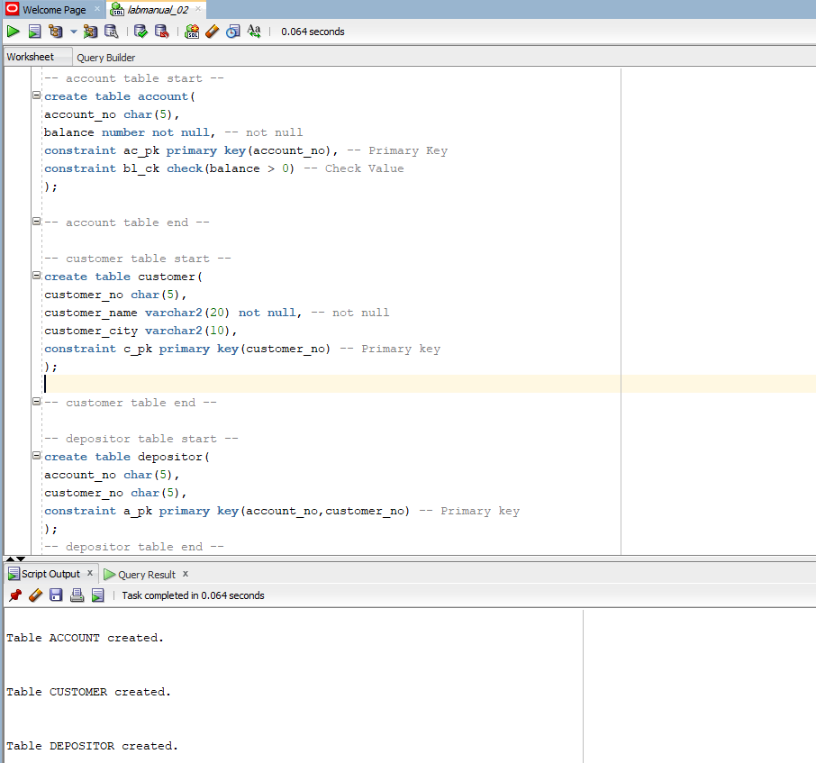

**Lab Task # 02 (Schema Modification):**

1. **Write SQL statement to add a new attribute ‘date_of_birth’ (date type) in customer table.**

1. **Write SQL statement to drop the attribute ‘date_of_birth’ from customer table.**

1. **Write SQL statement to rename the attribute account_no, customer_no from depositor table to a_no and c_no, respectively.**

1. **Write SQL statements to add two foreign key constraints ‘depositor_fk1’ and ‘depositor_fk2’ which identifies a_no and c_no as a foreign key.**

**

**Lab Task # 04 (Queries):**

1. **Display customer name and customer city only.**

1. **Display the unique customer city. No repetitions are allowed.**

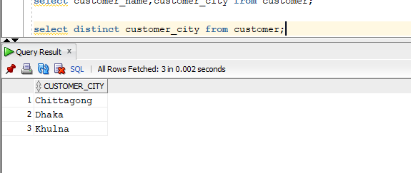

1. **Find account numbers with balance more than 7000.**

1. **Find customer number and customer name who live in Khulna.**

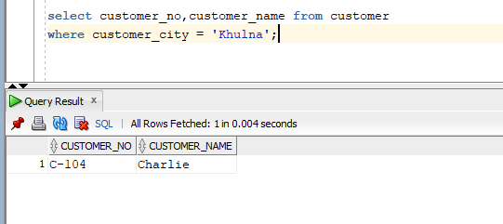

1. **Find customer number and customer name who do not live in Dhaka.**

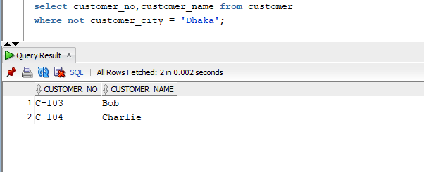

1. **Find customer name and customer city who have accounts with balance more than 7000.**

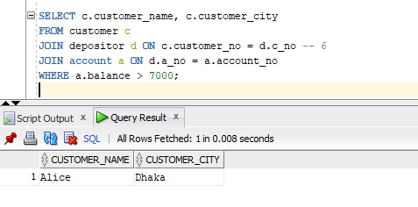

1. **Find customer name and customer city who have accounts with balance more than 7000 and do not live in Khulna.A screenshot of a computer program

   Description automatically generated**
2. **Find account number and balance for those accounts which belong to a customer with id ‘C-102’.**

1. **Find all account number and balance for those accounts which belong to customers of Dhaka and Khulna city.**

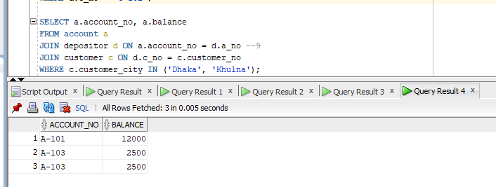

1. **Find the customer who have no accounts.**

